Pre-LOI Proforma
Cheat sheet · how we underwrite a venue before LOI
Walters Hospitality

1. Frame the venue
Five questions that set the tone for every proforma
Performing or growth?  Already doing well  — or —  Growth opportunity | Vendor services  What they do today  vs. what we implement,  and how fast | Payroll  Overstaffed  — or —  Understaffed | Owner  Heavily involved  — or —  Hands-off | Market  Current market  — or —  New market

Also: our marketing to get events booked, not just vendor services.

2. Key terms
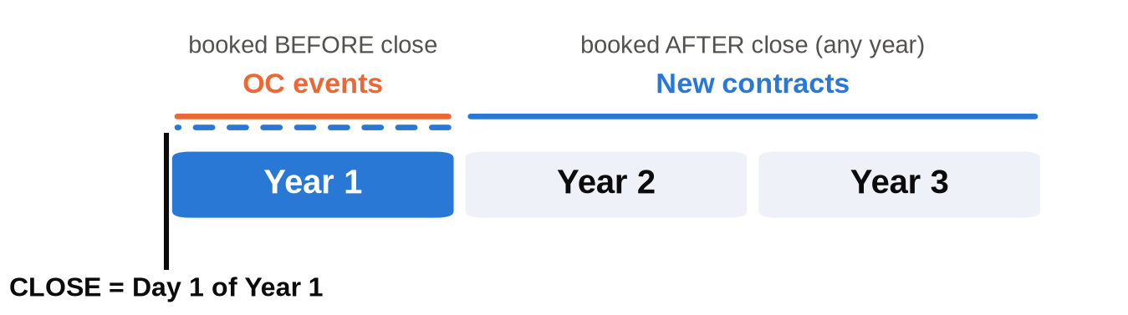
Year 1 / 2 / 3 | Proforma years. Year 1 starts the day we close — the moment we own it.
OC events | Original Contract events: already on the books before close. We want a healthy number — you can only book so many events into a year.
New contract | Anything we book after close, whether it lands in Year 1, 2 or 3.

3. Events — the three numbers
First thing we look at when projecting forward
1  Historical average  Events per year over their history | 2  Last 12 months  Events actually held | 3  Next 12 months  Events currently booked

4. Revenue & ancillary services
What they offer today · when we can implement · how fast we attach
Today: in-house bar? Required caterer? What else do they offer, and how?
Then: what can we implement, and when?
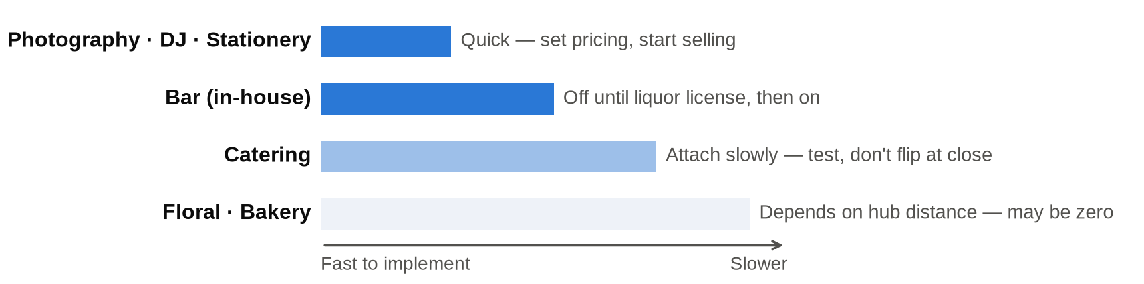
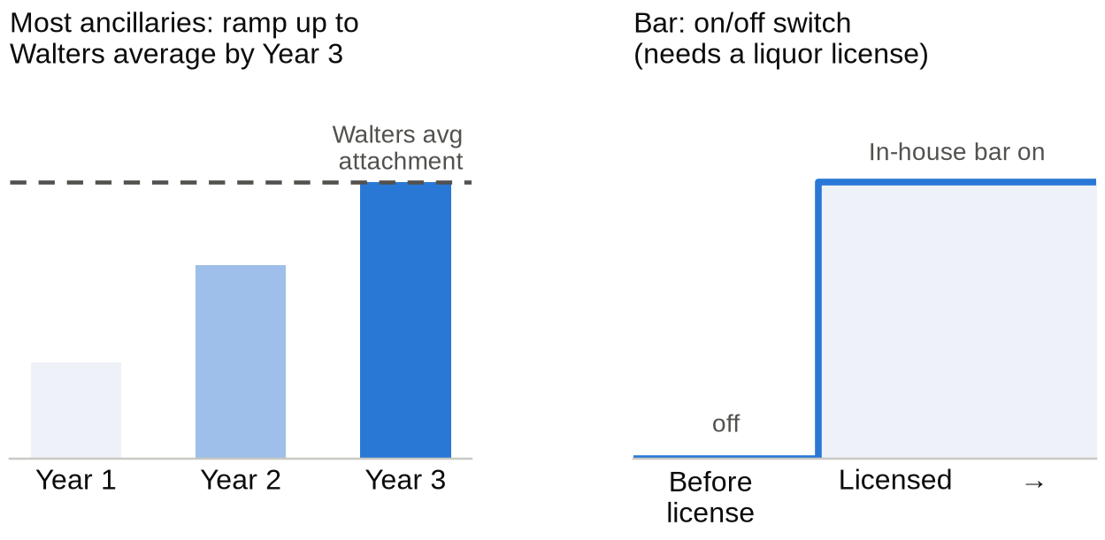
Attachment rate | Ramp up to the Walters average attachment for each service by Year 3. Tweak up or down for what they do today and what we truly believe we can do.
$ per ancillary | Use the Walters average $ per event for that service. Small venue → tweak down. Almost never tweak up. Sanity-check the implied $ per event against what the owner says brides actually spend.
Don't "Walterize" too fast | Flipping every package to standard at close can lose the brides that venue attracts. Test and attach slowly — never assume catering is 100% on day one.

5. Current vs. new market
Current market = within 90 minutes of our hubs
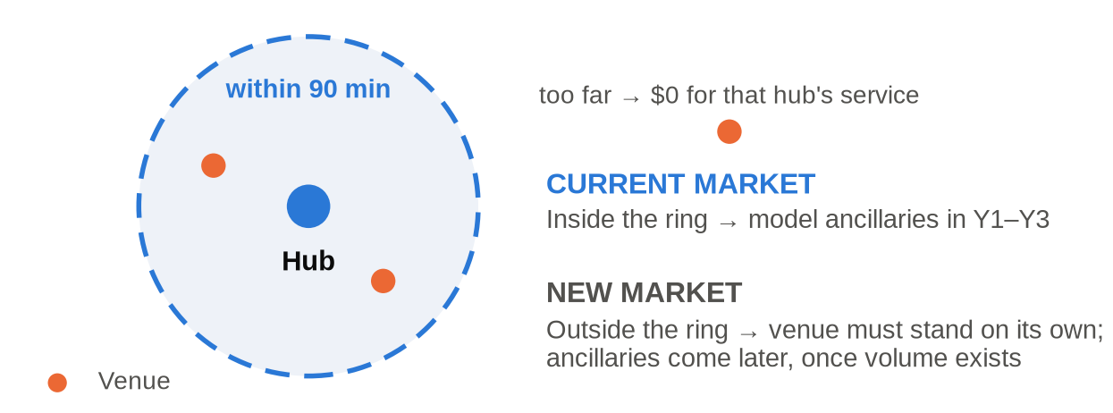
Dallas hubs | The Olana (bakery + floral) · one of our three catering hubs, whichever is closest
Rule | Model each ancillary against its own hub. 30 min from catering but 1–2 hrs from bakery → catering yes, bakery $0.
New market | Think further out. Needs to be a venue that already does well on its own; ancillaries may not come for a couple of years, once volume exists.

6. Expenses
A mix of what they do today and what we can and should do post-close
COGS  Venue-rental-only → little COGS today  Add COGS for each ancillary we attach  Required caterer? Carry their per-head cost on every OC event; set what we charge going forward | Payroll  Don't assume big cuts — they're likely staffed about where we'd be  Overstaffed or understaffed?  Owner's pay and replacement cost → see 7 | Operating expenses  Multiple lines  Start from what they spend today  Adjust to how we'd run it post-close

7. The owner question
How involved are they today?  Day-to-day operations, sales, or both? | What do they pay themselves?  Is it in payroll — or not? | If they walk away…  Who replaces them, and at what cost?

